Implicit Association between white people and Black People with Weapons
Student’s Name
Psychology 1200

Introduction and Background
An implicit association test, also known as (IAT), denotes to tests that provide an assessment of a person’s connection with different concepts. It determines how fast a person responds to certain concepts. It does so by determining responses across two related aspects using an attribute (Nock & Banaji, 2007). The text opines that whenever there are two concepts with a high correlation, and they share a key, the response is faster when compared to those that do not have any relationship. Even though the latter may share a key, the response is much slower since there is no association (Hofmann et al., 2005). The difference is quite important since it is used to determine the differential association in the presence of an attribute in two categories. The IAT is also quick to respond to near-universal evaluative differences, individual differences, expected differences, and consciously disavowed evaluative differences. It is also imperative to note that while an implicit association is unconscious, an explicit one is conscious. While individuals can possess negative implicit associations when it comes to their attitudes towards others, their explicit thoughts may not necessarily imply implicit association. For most people, the attitude towards different aspects is implicit because there is a tendency to classify everything under the same group. The categorization is part of a thought process that simplified everything among human beings.
The same can lead to stereotypes that refer to beliefs and misconceptions about others. In this case, individuals fit certain groups of people into clusters that define who they are. The stereotypes are mostly premised on race, religion, sexual identity, age, disability, and so on. Stereotypes inform many aspects among individuals. They determine the thought process and cognition involved in the interpretation of different events. They can also affect how people remember the occurrence of events. Implicit bias is especially detrimental to the aspect of memory. For example, there are eyewitnesses who tend to have false memories (Helm et al., 2016). Their bias against African Americans, for instance, may lead them to believe that a black person they encountered committed a crime even when this is not the case. In implicit associations, a witness may connect a certain crime to a person’s race, which can lead to false memories during the identification process. Implicit associations have serious consequences on the people that they affect. For example, the justice system is often flawed because of implicit associations. The justice system relied on the common phrase innocent until proven guilty. However, this is not often the case when jurors are listening to cases involving minorities. The same has led to some defense attorneys finding ways of determining implicit biases among jurors. They can then exclude them from trials to give their clients a chance for a better outcome. At the same time, prosecutors can have jurors with an implicit bias to increase the chances of a guilty verdict. The situation leads to Disproportionate minority contact (DMC), which is a term used to refer to the ill-treatment of minorities in the criminal justice system. It is a serious problem in the juvenile justice system. A study was carried out among 482 juveniles to determine the onset of DMC. The study showcased that DMC is not explained by aspects such as age or gender, but rather, white people’s implicit association of blacks and weapons.
African Americans are more likely to be perceived as criminals than other racial affiliations. Nonetheless, data is still lacking on the implicit association in this situation. Whites posses more superiority in the media and, therefore, have an upper hand when it comes to influencing the stereotypes in the society. The media has perpetuated negative stereotypes about African Americans and led to situations where whites influence implicit bias (Rodgers & Robinson, 2017). The paper will hypothesize that white people have an implicit association between blacks and weapons.
Methods
In this research, 1084 people completed a MyPsychLab activity. 623 of these participants were whites who consisted of 346 females and 277 males. 169 of the participants were African Americans who comprised of 117 females and 50 males. The participants also included Asian Americans, Native Americans, and other ethnic affiliations that were represented by 91, 9, and 89 individuals respectively. The participants were between the ages of 11 and 75 even though the standard deviation remains unknown.
Measures
The study utilized an implicit association test that is located on MyPsychLab.
Procedure
There was an Implicit Association Test on MyPsychLab activity that every participant was required to complete. The process was simple. The students were required to go to the mypearson and proceed to click on PSYC-1200-C01. The activity is located under the due items in the course roaster. The test involved the classification of words and images. The individual is supposed to be very fast while limiting mistakes. There were a total of seven trials; where trials 1,2,3,5, and 6 were used for practice. The rationale was to ensure the student understood the process before they completed the actual trial. Trials 4 and 7 were the actual ones used to create an analysis. Their data was taken and used to test the hypothesis. The first trial involved the placement of African Americans on the left while whites remained on the right. In the second trials, the weapons could be found on the right side while other non-violent objects were on the left. Trial 3 and 4 maintained this position. The fifth trial consisted of African Americans being found on the right and whites on the left. In the sixth trials, white people were placed together with harmless objects while African Americas were clustered with weapons on the other side. The sequence remained the same for the seventh trial.
The following table is a representation of the results gathered during the study.
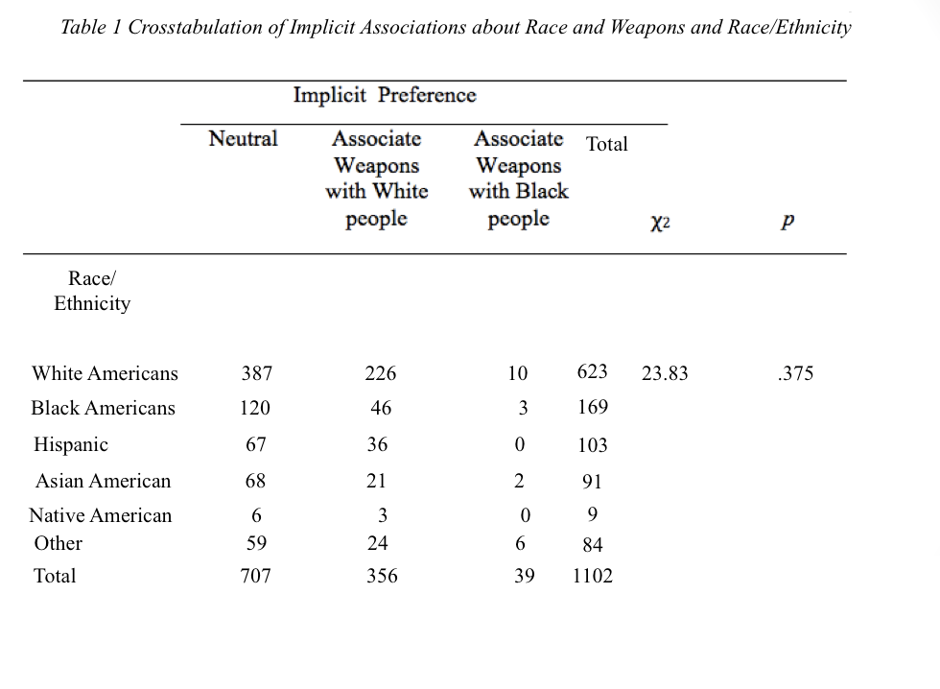
According to the hypothesis mentioned earlier, there is an implicit association among white people that connects African Americans to weapons. However, the results indicated that race is not a determining factor of implicit association when it comes to weapons. The hypothesis was not confirmed by the study results. The results found that 62% (387) of white people were neutral with regards to implicit associations. They did not have any racial stereotypes that would lead to their associating African Americans with weapons.
Nonetheless, 226 people who were 32% of the overall population showcased an implicit association. It is imperative to note that in this study, the race was the independent variable while the dependent one was an implicit association. The results indicated a lack of implicit association between race and weapons as indicated in the following formula; x²(10) = 23.83, p = .375.
Discussion
The study aimed to determine whether or not the aspect of the race created any implicit associations that related weapons to race. The results facilitated by the IAT showcased no implicit association when it comes to race. In this case, the majority of the individuals did not think that African Americans should be associated with weapons. The results imply denouncing traditionally conceived notions about African Americans being associated with weapons. They showcased that race does not formulate an implicit association that is used to make this judgment. Therefore, there was a need for more examination into other defining factors that could be causing an implicit association in this subject. For instance, researchers needed to explore aspects such as gender and age. The study can also lead to a scrutiny of the recent school shootings that have all been perpetuated by white people. It could lead to the inference that white people have a strong inclination towards weapons, which can then create an implicit association. The same study can also lead to questions regarding the role of gender and possession of weapons. Questions arise about whether race truly is a factor or there are others at play such as the gender of the person, given that mass shootings have been orchestrated by men. There is a need for more studies to shed light into these questions.
However, the study has limitations that would make it impossible to conclude. For instance, IAT as a method for this study is too limiting to decipher any existing relationship between race and weapons. There were also different approaches to the exercise. While some students found it easy in the beginning and answered it quickly, others preferred to go steadily and believed it would become easier as they went along as per the rules of the learning curve. The type of hand one used (left or right) may have had impacts in the results as well since individuals may have faced some difficulties navigating the fast test with less dominant hands. Even so, the study had the strength of a large sample population. The same gave the results more consistency since there were numerous answered indicating a similar hypothesis.
Notwithstanding this strength, it is imperative to note that the number of females was significantly higher than that of males. The ethnicities participating were also not balanced since some races had very few representatives, which may have affected the validity of the results. In the future, a different test should be employed, and the study can be expanded to include images reflecting various socioeconomic backgrounds.

References
Helm, R. K., Ceci, S. J., & Burd, K. A. (2016). Can implicit associations distinguish true and false eyewitness memory? Development and preliminary testing of the IATe. Behavioral Sciences & The Law, 34(6), 803.
Hofmann, W., Gawronski, B., Gschwendner, T., Le, H., & Schmitt, M. (2005). A meta-analysis on the correlation between the Implicit Association Test and explicit self-report measures. Personality and Social Psychology Bulletin, 31(10), 1369-1385.
Nock, M. K., & Banaji, M. R. (2007). Prediction of suicide ideation and attempts among adolescents using a brief performance-based test. Journal of consulting and clinical psychology, 75(5), 707.
Psychological Association.
Rodgers, N., & Robinson, R. (2017). How the news media distorts black families. American

